Dr. Sowmya Badina

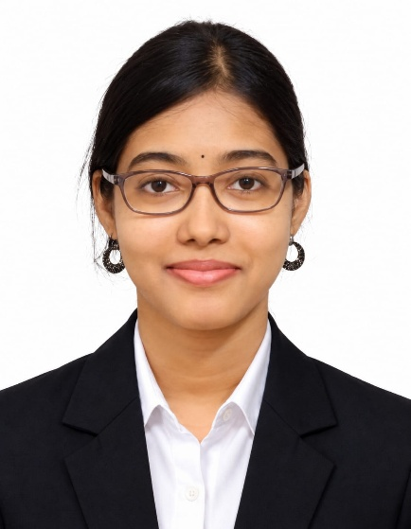

Clinical Data Scientist | Health Informatics & AI in Healthcare
Dr. Sowmya Badina is a dynamic healthcare professional and alumnus of The Apollo University, whose career brings together clinical dentistry, health informatics, bioinformatics, data science, and artificial intelligence. Her journey reflects the evolving role of technology in healthcare and demonstrates how interdisciplinary knowledge can be used to address complex clinical and research challenges.
She completed her M.Sc. in Health Informatics and Analytics from The Apollo University, Andhra Pradesh, from 2022 to 2024. During her postgraduate studies, she developed expertise across healthcare data science, epidemiology and biostatistics, clinical decision support systems, data visualization and analytics, clinical informatics, machine learning, AI in healthcare, and health data management.
Prior to this, she completed her Bachelor of Dental Surgery (BDS) from Vishnu Dental College, Andhra Pradesh, building a strong foundation in clinical dentistry and patient care.

Professional Journey
Dr. Sowmya currently serves as a Clinical Data Scientist at the Centre for Digital Health and Precision Medicine (CDHPM), Apollo University. In this role, she works on the development of agentic AI solutions for digital healthcare applications, including voice-based patient assessment and automated analysis of clinical communication. She also develops healthcare analytics pipelines that generate structured insights for clinical training and decision support. Her work involves collaborating with clinicians, researchers, and multidisciplinary healthcare teams to transform clinical requirements into scalable, data-driven solutions.
Her research experience also includes working as a Clinical Research Trainee at Brigham and Women’s Hospital, Boston, USA. There, she analysed more than 458 genomic samples to investigate allele-specific expression patterns related to kidney disease. Through genomic data analysis, statistical methods, bioinformatics techniques, and WASP-based bias correction and filtering approaches, she contributed to improving the accuracy of ASE quantification by 20%.
Her early professional experience as a Trainee General Dentist at Vishnu Dental College and Hospital provided valuable clinical exposure. She conducted oral health assessments for more than 450 patients and provided a range of dental treatments to over 200 patients, developing a strong understanding of clinical practice and patient-centred care.

Research & Publication
Dr. Sowmya has contributed to research in human kidney genomics and allele-specific expression. She is a co-author of the research publication:
“The landscape of allele-specific expression in human kidneys.”
The work brings together researchers in genomics and kidney disease and reflects her contribution to computational and bioinformatics-based biomedical research.

Areas of Expertise
- Clinical Data Science
- Health Informatics & Analytics
- Artificial Intelligence in Healthcare
- Agentic AI & Large Language Models
- Retrieval-Augmented Generation (RAG)
- Machine Learning
- Conversational AI
- Bioinformatics & Genomics
- Clinical Research
- Healthcare Data Analytics
- Python, R & SQL
- Data Visualization
- Clinical Decision Support
Her technical skill set spans Python, R, SQL, machine learning frameworks, AI and LLM systems, data visualization, databases, genomics, transcriptomics, and Linux/Bash, giving her a multidisciplinary foundation for modern digital healthcare.

An Inspiring Journey
Dr. Sowmya Badina’s journey demonstrates the value of combining clinical knowledge with technology and research. From caring for patients as a dental professional to working with genomic data and developing AI-driven healthcare solutions, she has built an interdisciplinary career at the intersection of medicine, data, and artificial intelligence.
Her journey serves as an inspiration to Biomedical Sciences students to explore emerging areas of healthcare, embrace interdisciplinary learning, and use technology and research to contribute to the future of healthcare.

